YEAR 10 SCIENCE (ADJUSTED)
SEMESTER 2 EXAM QUESTIONS 2019

1. A train accelerates from rest at Whitfords Station and accelerates towards Greenwood station, reaching 35 m/s after 24 s.

(a) What is the train's acceleration? (Hint: Use v, u, a, t.) (3 marks)

(b) (i) Describe what happens to the passengers who are standing on the train as it starts off from the station. (1 mark)

(ii) Why does this happen? (2 marks)

2. Vincent dropped a stone down a well and saw it hit the bottom 3.5 s later. Calculate the velocity of the stone at impact, given the acceleration due to gravity is 9.80 m/s² and the stone starts from rest. (Hint: Use v, u, a, t.) (3 marks)

3. A force of 36 N acts on a mass of 24 kg. What is the acceleration of the mass? (Hint: Use F, m, a triangle.) (3 marks)

4. Consider the forces acting on the car in the diagram below. Calculate the nett force acting on the car. (2 marks)

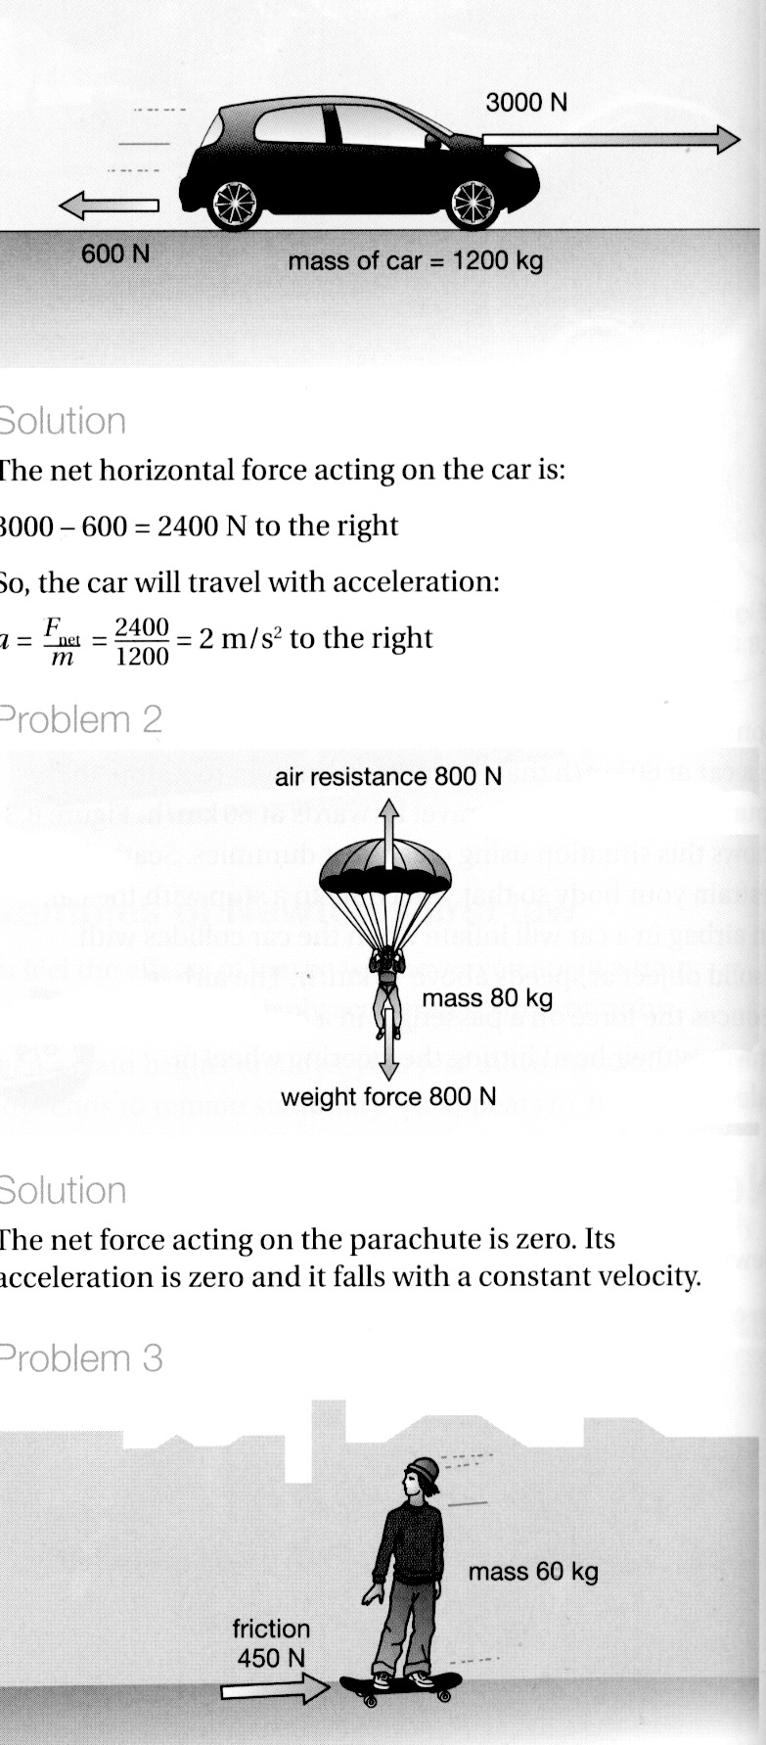

5. Max has a mass of 57 kg on Earth. He is lucky enough to be selected for a junior astronaut programme and journeys to the International Space Station (ISS) for a
3-month stay.

(a) Calculate Max's weight on Earth, where the acceleration due to gravity is
9.80 m/s². (3 marks)
(Hint: Use F_{w}, m, g triangle.)

(b) Max "floats” in space within the ISS. Is he weightless? Explain your answer.
(2 marks)

(c) What is Max's mass in the space station? (1 mark)

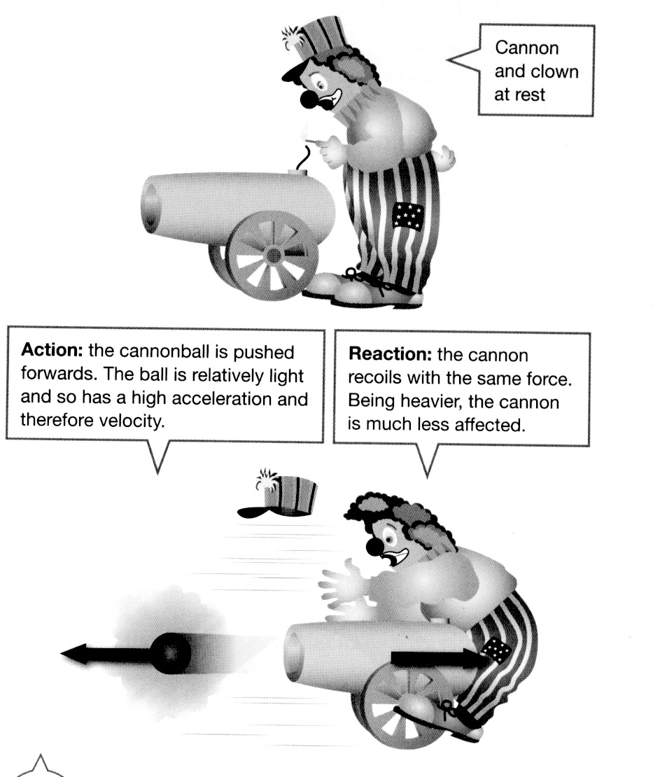
6. Look at the diagram showing a clown and a cannon at a circus.

(a) Which of Newton's three laws applies to this situation? (1 mark)

(b) Explain clearly why the cannon hits the clown. (2 marks)

